**SATURDAY CLUB FOOTBALL LEAGUE TEAMS**

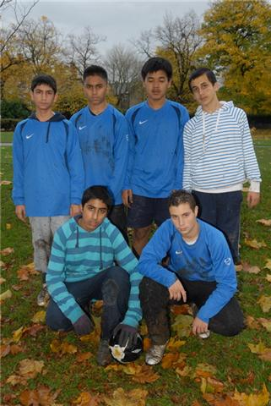

**Team name: Asia Utd  
Back row L to R: Quais Fazli, Sarwar Ali, Wantana Kaewpanya, Tamim Khohistani,  
Front row: L to R: Zeeshan Ahmed, Abdel Karim Sharif**

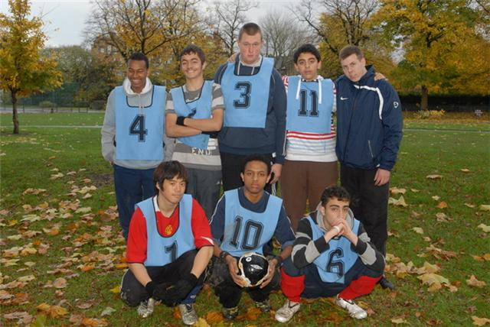

**Team name: Saturday Club A  
Back Row L to R:  Mohammed Ali, Lirim Shabani, Jaimie Rank, Bashir Massadi, Collin Lidl,  
Front Row L to R: George Watana, Giosaf Bogkale, Tariq Asfar**

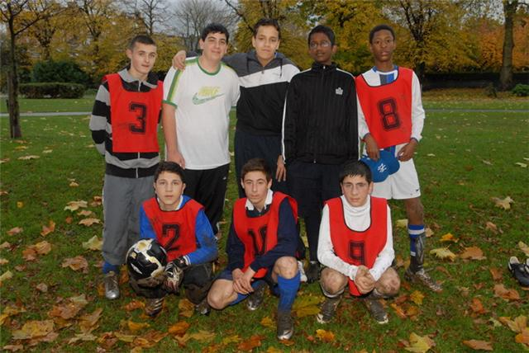  
 **Team name: Compton All Stars  
Back row L to R: Shaun Sheridan, Andrea Serino, Harry Wills, Nikalas Manuel Pilay, Dominic Redhead**

**Team name: Armenia  
Front row: Karan Pogosvan, Vardan Franguljan, Ash Poghsoyan**  
  
 

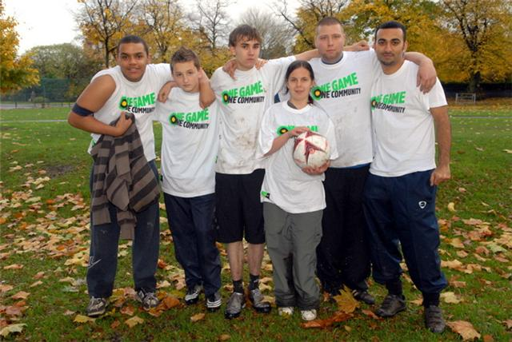  
   
**White Tshirts:  
Team name: Saturday club B  
Back row L to R: Amir Anwar, Florian Rafuna, Steven Sarin, Sarah Louise Hardy, Nathan Fisher**

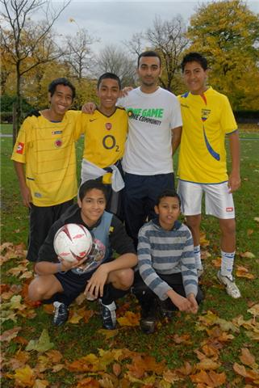

**Team name: Sangre Latino  
BR L to R: Bryan Rodriguez, David Santiago, Jefferson Valle  
FR to R: Allan Viana, Walid Fuad**